Student
Institution
Course
Date
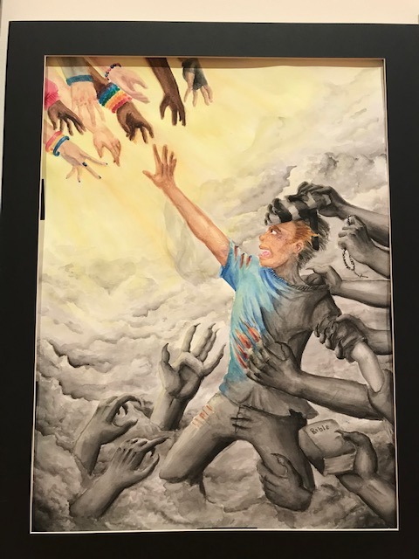

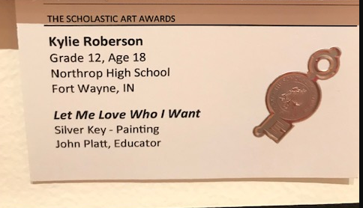

Artwork
The art that I chose for this paper is painting by Kylie Robertson, called “Let me Love Who I want.” The reason as to why I chose this painting is because it is painting a thousand words to the viewers. The artist concentrated on reflecting on his feelings. Looking at the painting enchants me to it. The artist succeded in passing his message in a coded way. Every art contains different pattern, color, pattern,tone, shape, line, texture and form. The artist was able to use all this buildings blocks of composition in art to pass the message. As the title suggests, the artist felt that there was need for one to make decision whether to be saved and live in a Christian way of life, or follow the earthly way of life. As it is going to be described in this paper, the man in the painting seems like he has decided to leave the evil and earthly possessions world and follow God.
The selection of colours is also very outstanding. In the painting, there is a man who is running away from several hands that looks like they want to grub his hand. The hands that he chooses to be with looks like they are Godly ones because there is a bible held by one hand and a cross necklace. The painting is reflecting on leaving the worldly things and living in a Godly manner.
The artist wanted to express different things by using the painting. There are different elements in the painting that are sending different messages. The first one is the cross necklace. This is worn by Christians showing that which features crucifix. They are purchased on the stores or given as gifts for confirmation after baptism. Crosses are used as a commitment to the Christian faith. Christians believe that wearing a cross offers one protection from evils. Thus, in the picture, the hands that the man is running away from being evil and the hands in the opposite bottom left side are Godly ones. The man seems to have chosen to stay in a Godly way. The bible says that one must fight for the right things, in a right way and with the right motive. Thus, it doesn’t matter how difficult it is, a true Christian must go for righteous and abandon the earthly desires.
The second element that appears in the painting is the bible. The bible is a symbol of the word of God. Bible is used to transmit God’s idea to human beings. Christians believe that God will judge the people and assign them different sorts of afterlives according to what they did while they were human. The bible is a light that casts out darkness. The bible has an outstretched arm that symbolizes the might power. In the painting, the bible is used to symbolize that the man needs the bible to be guided on how to live in a Godly way. After the man chooses to leave evil, he will be using the bible to transmit God’s idea to him. through this, the man will not be subjected to painful condemnation for being unfaithful to God. The outstretched arm shows the mighty power of God that will protect the man from evil.
The third element that the artist used to paint a clear picture to the viewer is the use of different colours. In the Godly side, the artist used one colour which can be interpreted that God’s way is the same and doesn’t change with time. The Godly side is black and white which is associated with the ancient way of living. On the other hand, the earthly side is coloured in different colours such as brown, black, blue, yellow, red and grey. This shows how the world is changing with time. When I saw the painting for the first time, it intoxicated me and I found myself trying to figure out the meaning that the artist wanted to paint to the minds of the people. The selection of different colours is what came first to my mind. Having coloured pictures shows how enticing and beautiful are earthly things. A man must choose to leave the beauty of the world and follow the Godly way.
Another element that is noticeable in the painting is the use of different colours on man’s body. One half of the man’s body is coloured while the rest of the man’s body is black and white painted. This shows that the man is still indifferent in choosing between the two. However, better parts of man’s body seem to be in God’s side which shows that man finally chooses to go to the spiritual side and leave the world, though he is still staring at the world things. Through the Bible and the crucifix is going to help the man to live a Christian-like life.
The bangles on the hands-on earthly side symbolize traditional culture. The different bangles represent different cultures in the whole world. They are worn on different occasions bearing different meaning depending on the culture in the subject. Currently, bangles are used to suit the contemporary look. This symbolizes that man should leave all traditions and leave in a Christian way.
The last element that I was able to identify in the painting is racism. The top hands have different colours, while the bottom hands are in one colour. Identifying people in terms of their skin colour is racism in a way. On the other hand, the same colour shows that in God there is no racism and everybody is equal in God’s eyes.
In conclusion, this painting is very effective because the artist was able to paint different meaning concerning Christianity by the use of a single painting. It’s a snapshot of Christian life and the things have to leave before converted fully to Christianity. As the title suggests (Let me love who I want), to be a Christian you need to make a choice, either to love God or to love the worldly things.

